**The Battle of the Neighborhoods**

## Introduction

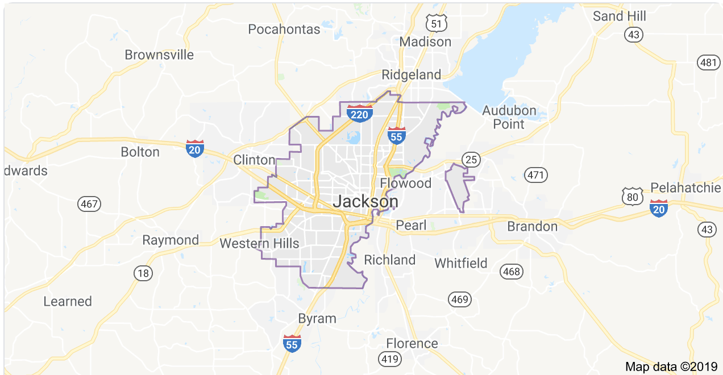Jackson, Mississippi has recently become a haven for Millennials looking to escape the fast pace life and settle for more of a serene backdrop.

Within the last year data shows a 20% increase in new residences between the ages of 25-35. The current resident population in the area is 166,965, numbers represent residents who reside in the central metropolis. With a steady stream of growth, cost conscience millennials are looking for the best real estate options for their dollar and that are in close proximity to nearby venues.

**Problem to Solve:** Identify the best neighborhood within the Jackson, Mississippi geographical area as a potential location to purchase a home based on sales tax data and proximity to amenities.

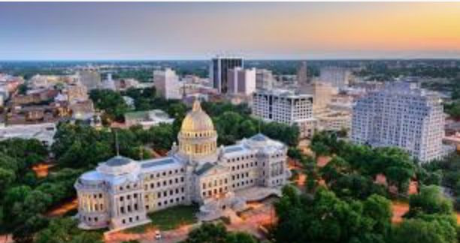

**Persona:** 1st time buyer, married couple with combined income of $109,000.

**Persona Desires:**

* Low sales tax
* Close proximity to venues

**Scenario:** Potential new homeowners would like to explore gross sales tax data and gain venue insights by neighborhood to examine the impact on their spending potential.

## Data

**2.1 Approach**

I will be extract and examine local gross sales tax data and utilize the Foursquare API to expand exploration of the neighborhoods. Data extrapolations from Foursquare will provide common venue insights and help home seekers with the data to determine which area best aligns to their interest.

Data was sourced from three primary data sources.

* 1. MS Department of Revenue
     + <https://data.jacksonms.gov/api/views/d36h-vd4y/rows.json?accessType=DOWNLOAD>
  2. Zillow
     + https:zillow/data/research
  3. Foursqure
     + https://foursquare.com

**2.2 Tax Data**

I will be using data from the MS Department of Revenue specific to the City of Jackson. It is compiled from Gross Sales Tax reported by taxpayers each month. Gross Sales Tax is the total amount of tax and does not include any discounts, credits, penalty, or interest. The data used is updated monthly.

**Note**: Data is in *json* format and will be transferred into a pandas dataframe.

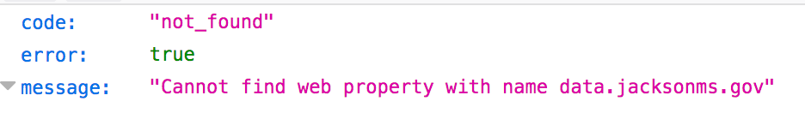

Figure 1. Sales Tax Data Error Message

A careful review of the site where the data was contained revealed the above error.

**2.3 Home Sales Data**

As result, I am unable to proceed as originally planned using gross tax sales as a cross comparison to identify areas with low sales tax collections as a determination along with venue proximity for selecting the best neighborhood within the Jackson, MS area. I will shift my analysis to exploring housing data extracted from this [site](https://zillow/data/research).

Data collected from Zillow provides information on home listings and sales.

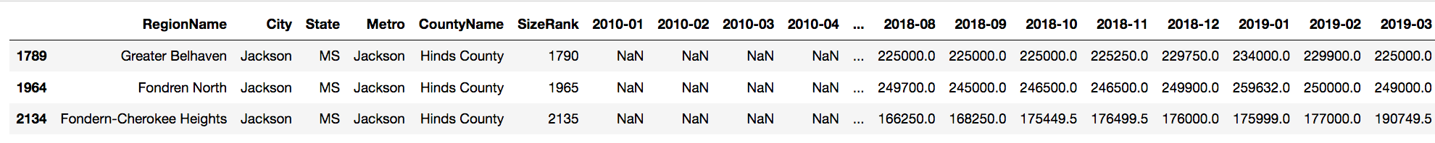

Figure 2. Jackson Neighborhood Data

## Analysis

**3.1 Approach**

In order to determine proximity to venues a breakdown of the three regions will be reviewed. Co-ordinates or latitude & longitude will be obtained by passing the RegionName value through geocoding.

|  |  |  |
| --- | --- | --- |
| **RegionName** | **Latitude** | **Longitude** |
| Belhaven, Jackson, MS | 32.3201811 | -90.1690766468281 |
| Fondren, MS | 33.3534553 | -90.358419 |
| Cherokee Heights, MS | 33.4762328 | -88.827832 |

Table 1. Co-ordinates Data

The Foursquare API will be used to find venues within a 500 meters radius of the three neighborhoods identified within the Persona’s purchasing range. Data returned shows limited number of venues present within each core Region being analyzed.

**3.1 Results**

|  |  |
| --- | --- |
| **RegionName** | **# of Venues** |
| Belhaven, Jackson, MS | 4 |
| Fondren, MS | 0 |
| Cherokee Heights, MS | 0 |

Table 2. Venue Data

|  |  |  |
| --- | --- | --- |
|  |  |  |

Figure 3. Jackson Neighborhood Data

## Conclusion

Greater Belhaven returned highest number of venues and should thereby be considered as the optimal location